RESUME

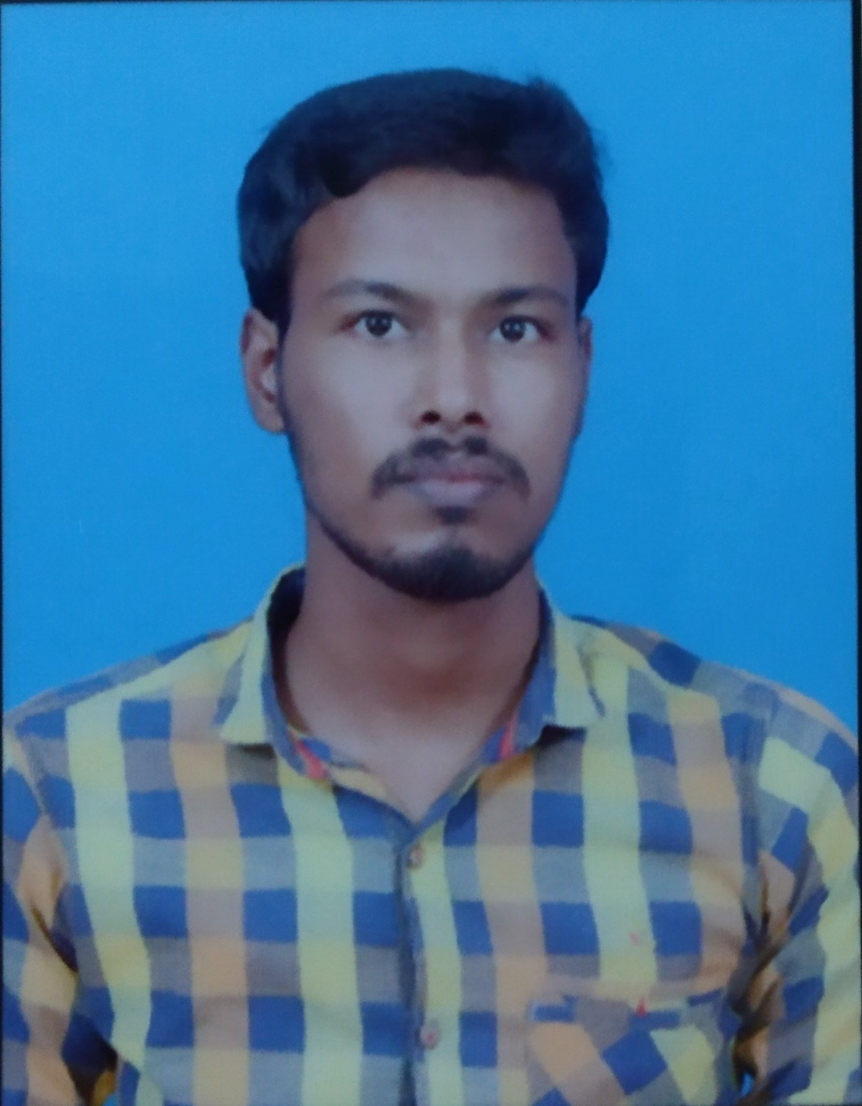

Mr.V.MANOJKUMAR

OBJECTIVE

To obtain a challenging position that fully utilizes my skills and provides me with suitable opportunities to grow my technical and communication skills which would help me as a fresher to grow while working towards the organizational goals.
EDUCATION

Degree | Specialization | Institution | University | Year of Graduation | Marks Obtained  (% or CGPA)
B.E | Mechanical | R.V.S.College of Engineering and Technology | Anna University | 2022 | 7.8
HSC | Biology and Mathematics | Syed Ahmed Hr,sec.school |  | 2018 | 56%
SSLC |  | Syed Ahmed Hr,sec.school |  | 2016 | 88%

ACHIEVEMENTS AND AWARDS

- Nill
ACHIEVEMENTS AND AWARDS

AREAS OF INTEREST

- Designing
- Software Developing

SOFTWARE PROFICIENCY

Programming and : Proficient in: Python
Script Languages

Tools and : Proficient in: AUTO CAD, Excel, CNC
Technologies

Operating Systems : Windows XP.

PROJECT WORK

- Turbocharger in Two Wheeler

- Wind tunnel

CERTIFICATION COURSES

- CNC

CO-CURRICULAR ACTIVITIES

- Webinar – Recent Trends in Mechanical Engineering
- Webinar – Lean Manufacturing Systems
- State Level Online Quiz on ‘‘CHEMICAL ENERGY’’
- Workshops - Team building

EXTRACURRICULAR ACTIVITIES

- Sports
- Dance
PERSONAL DETAILS

Date of Birth : 30-11-2001
Father’s Name : A.Vivekanathan
Mother’s Name : V.Anitha
Address : 342, Middle Street, Thoruvalur(po),Ramanathapuram - 623530
E – Mail ID : manojkumar782688@gmail.com
Languages Known : Tamil, English

Declaration: The information furnished above is correct to the best of my knowledge.

Date: . .20 Yours sincerely
Place: Coimbatore V.Manojkumar

